

Airlink   
SMA Report V3.2

29/05/2017 Prepared for: Airlink UAE



Table of Content

1. Database Report 3

2. Infor WM Environment Report 14

3. Boomi Report 18

4. Miscellaneous 20

5. Acknowledgment 21

1. Database Report

Title of Chapter

Executive Summary

Upon analyzing the Oracle Indicators, the database performance is very solid. Elsewhere, the health and security of the database are also solid.

Specifications

|  |  |
| --- | --- |
| **Server Name** | EXCEEDDB |
| **Domain** | Airlinkjbl.ae |
| **Server Model** | IBM X3650 M3 |
| **Processor Model** | Intel Xeon E5620 |
| **Processor Speed** | 2.40 GHz |
| **Number of CPUs** | 16 |
| **Ram** | 14.0 GB |
| **OS** | Gnome 2.16.0 |
| **OS Mode** | 64 bit |
| **IP Address** | 192.168.3.223 |
| **Subnet Mask** | 255.255.255.0 |
| **Default Gateway** | 192.168.3.2 |
| **DNS Server** | 192.168.3.225 |
| **Oracle Version** | 10.2.0.1.0 |

Figure: Server Specifications

Overview

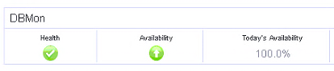



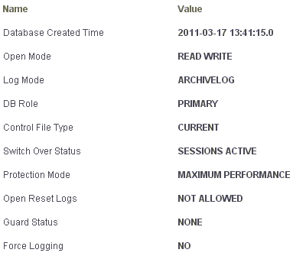

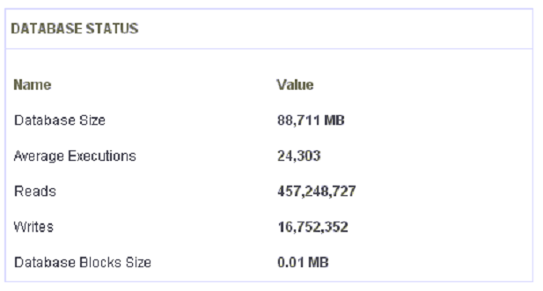

Database Alert Log

There were **0** traces logged in the Oracle Database “LIVE” for any deadlocks or blocking Locks. This undermines that the Oracle Database is able to resolve and manage the Locks occurring on the Database, and that no incoming Deadlocks are being provoked from the WMS Application utilizing the Database.

Policy Violations

The measurement of policy compliance is calculated as a percentage by using the database policy's severity, the importance of this policy for the target, and percentage of objects with violations. A low compliance score displayed in the policy violations table indicates that the target may need attention.

The database instance LIVE’s configuration is mostly compliant with reference to oracle standards and therefore no corrective action is required. The only violation logged by Oracle at the moment is:





Database Server Overview

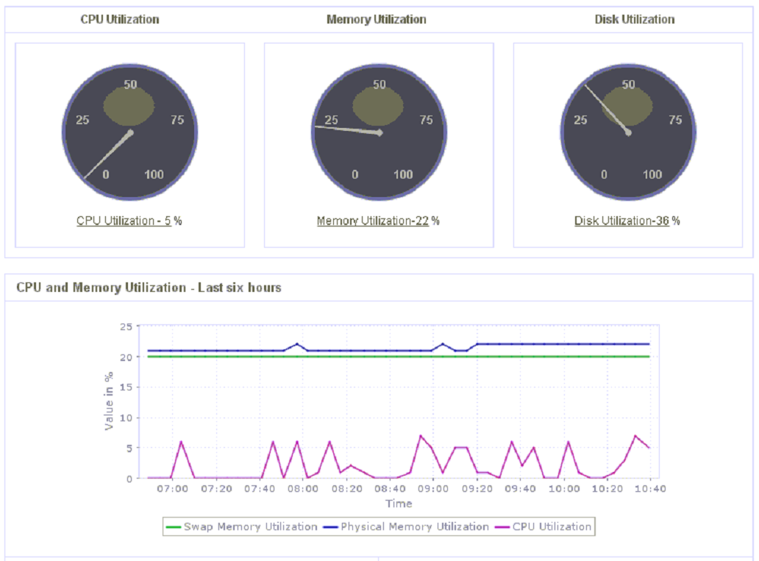

No abnormal values or excessive use of the server has been logged.

Database Server Disk

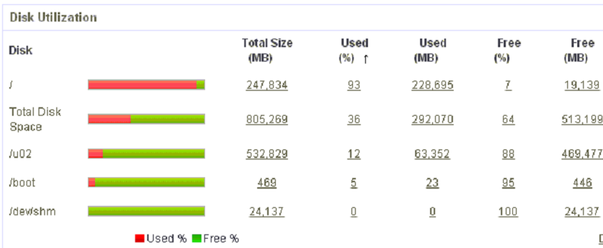

The drive isn’t able to write and read at the same time, due to its type, which affects the speed of reading and hence the performance of the system is slower. An upgrade would consist of a hard disk upgrade to SSD, or separating log files and data files.

Moreover, the root directory is almost full and it poses a threat in case tablespaces needed to be extended. A drive expansion is highly recommended.

Database Uptime

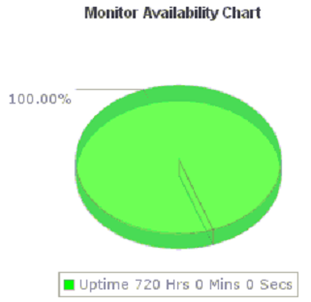

The database has been up 100% of the time.

Database Backup

|  |  |  |  |  |  |  |  |  |  |  |
| --- | --- | --- | --- | --- | --- | --- | --- | --- | --- | --- |
| **Day** | **1** | **2** | **3** | **4** | **5** | **6** | **7** | **8** | **9** | **10** |
|  | Y | Y | Y | Y | Y | Y | Y | Y | Y | Y |
| **Day** | **11** | **12** | **13** | **14** | **15** | **16** | **17** | **18** | **19** | **20** |
|  | Y | Y | Y | Y | Y | Y | Y | Y | Y | Y |
| **Day** | **21** | **22** | **23** | **24** | **25** | **26** | **27** | **28** | **29** | **30** |
|  | Y | Y | Y | Y | Y | Y | Y | Y | Y | Y |

Table 4: Backup

The backups are taken through RMAN.

ArchiveLogs were successfully kept during the whole period, allowing a quick automatic system restore in case of any DB Failure.

The backups still need to be tested for their readiness on a DR Server.

Physical Objects and Statistics

Top tables

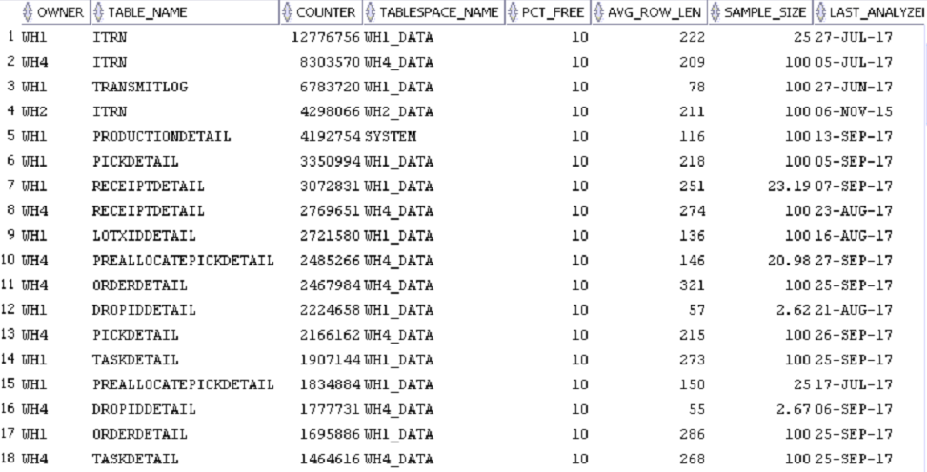

Archiving is not required at this point. Oracle’s default statistics management is taking care of the tables properly and no extensive row lengths were found.

At last, it is recommended to move the table PRODUCTIONDETAIL to tablespace “WH1_DATA”, though this would require downtime.

Tablespace

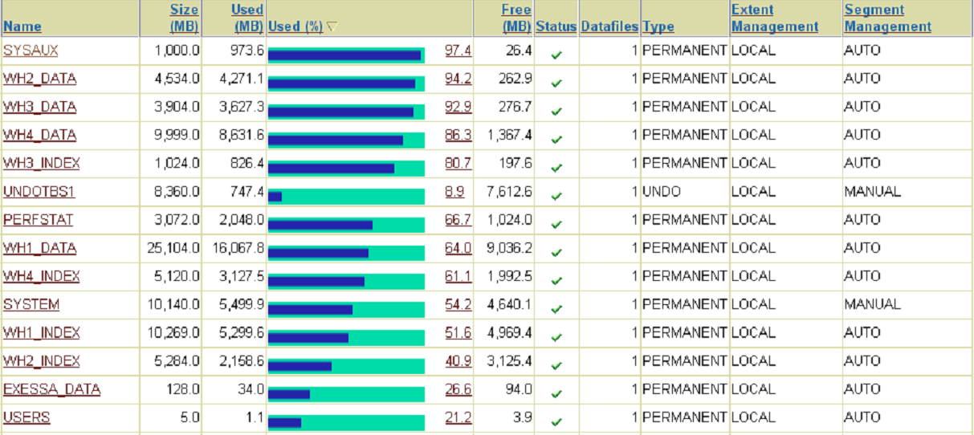

All WMS table spaces possess auto extendible data files. The average read/write performance is optimum.

WH3_DATA, WH2_DATA and WH4_DATA will auto-extend in the next few months. When they do that, they will need around 2GB off the hard disk which is in danger as the free space is becoming more and more limited.

Database Metrics

Metrics Audit

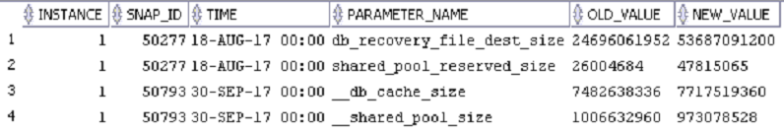

No change of metrics has been observed for the month of September 2017.

Users and Sessions

Response Time

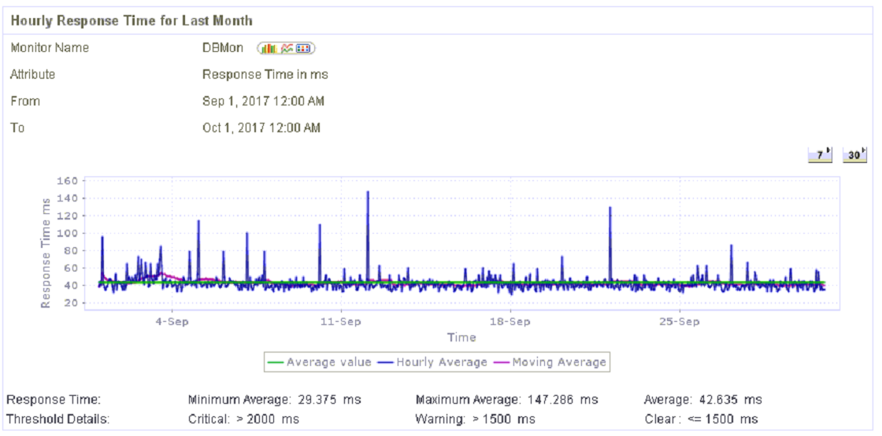

The graph shows no significant jump/peak in the response time.

Number of Users

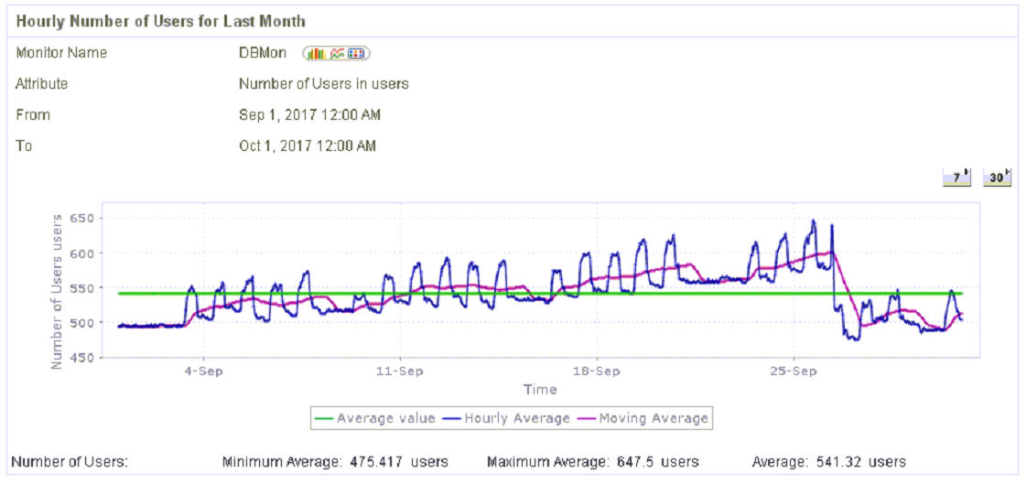

Database Performance

SGA

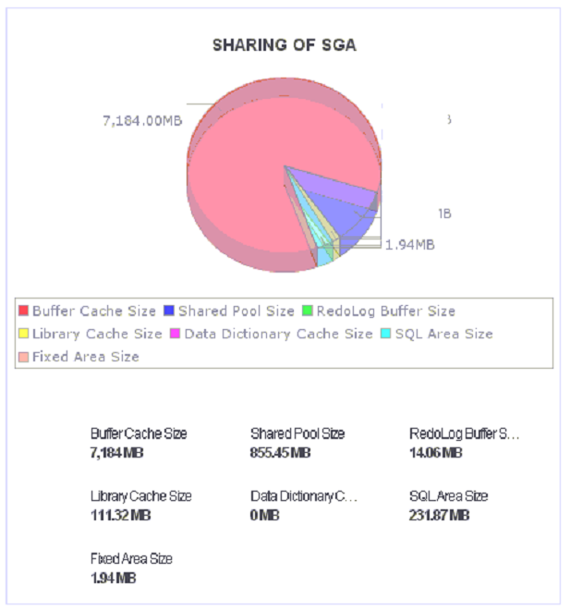

PGA

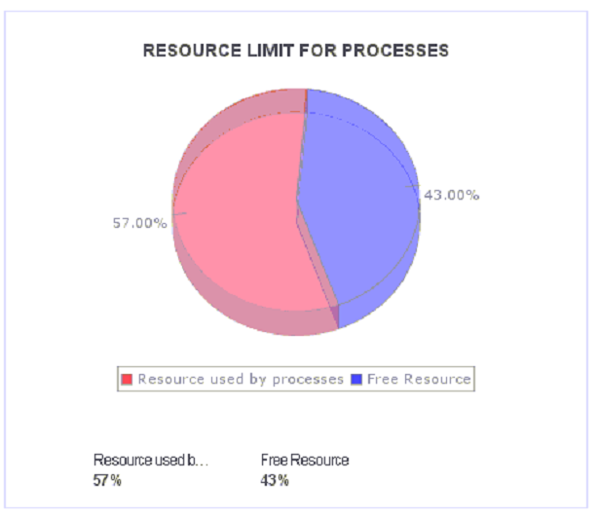

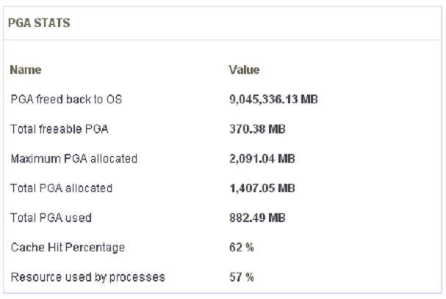

The cache hit percentage is low.

Oracle Indicators

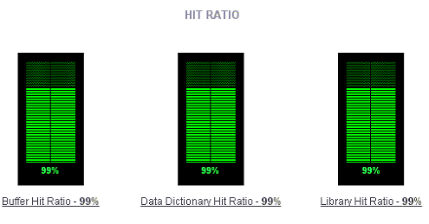

The database hit ratios indicate that the queries are being softly parsed.

Exhaustive Queries

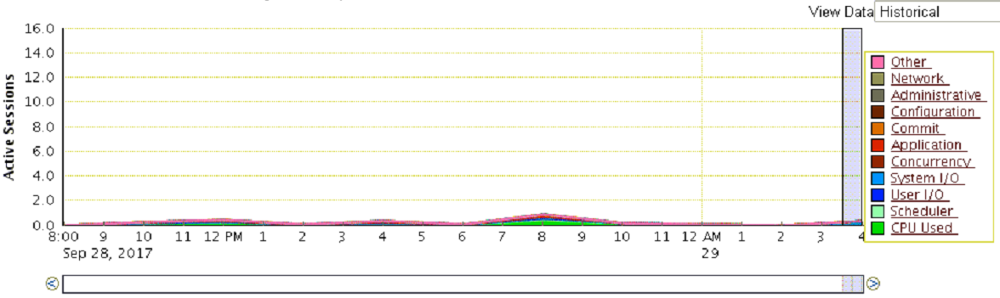

9.11.4 Notes:

Oracle Enterprise Manager shows that there aren’t any regular exhaustive queries or sessions being logged during the past week.

Oracle Alerts

No alerts were logged by Oracle Enterprise Manager during the past month.

1. Infor WM Environment Report
   1. EXCEEDAPPS

Server Specs

|  |  |
| --- | --- |
| **Server Name** | EXCEEDAPPS |
| **Domain** | Airlinkjbl.ae |
| **Server Model** | IBM x3650 M3 |
| **Processor Model** | Intel Xeon E5620 |
| **Processor Speed** | 2.40 GHz |
| **Number of Cpu's** | 16 |
| **Ram** | 8 GB |
| **Partition 1 'C:'** | 180 |
| **Partition 2 'E:'** | 97.6 |
| **OS** | Windows Server 2008 Ent SP2 |
| **OS Mode** | 32 bit |
| **IP Address** | 192.168.3.231 |
| **Subnet Mask** | 255.255.255.0 |
| **Default Gateway** | 192.168.3.2 |
| **DNS Server 1** | 192.168.3.225 |

Figure: Server Specifications

Server Uptime

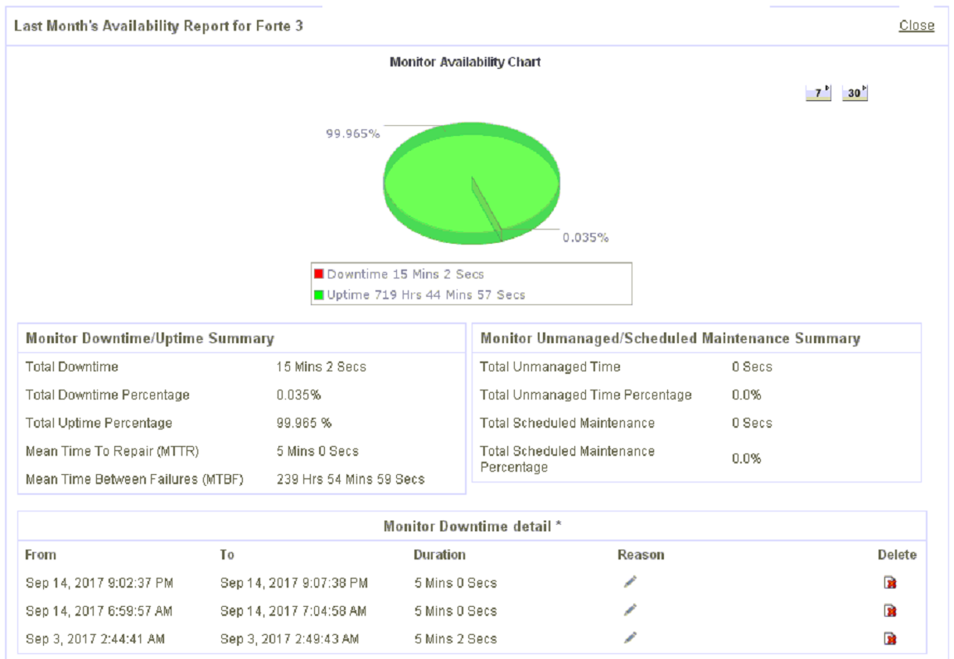

The FORTE3 server has been up 99.965% of the time during the past month. Several 5 minute downtimes have been recorded throughout the month which are due to disconnections.

Disk

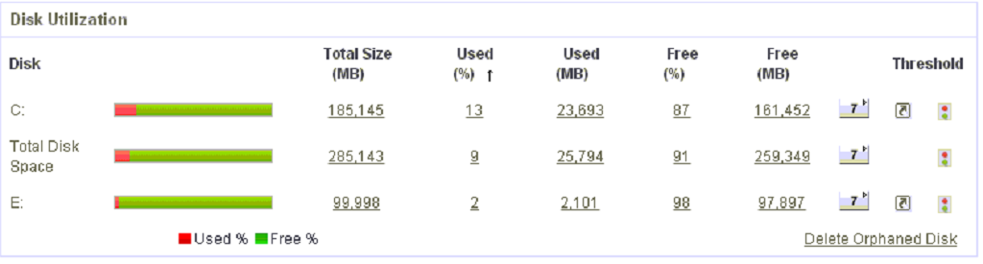

Server Overview

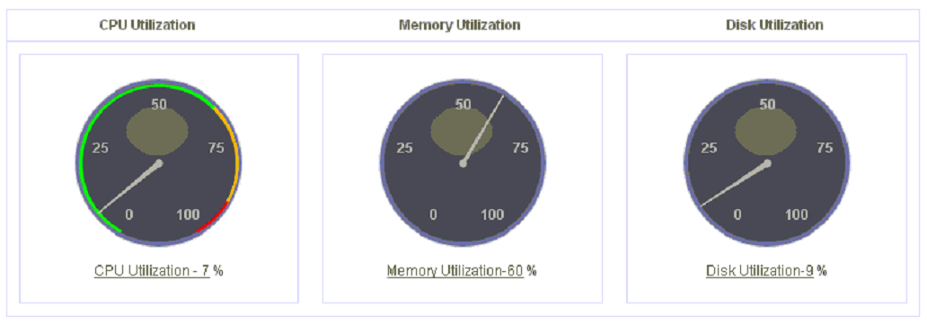

Error Logs

No error logs were found in event viewer or forte logs.

Replication Monitor

The replication monitor is running every 4 minutes. No log of dying replicas.

CPU Usage

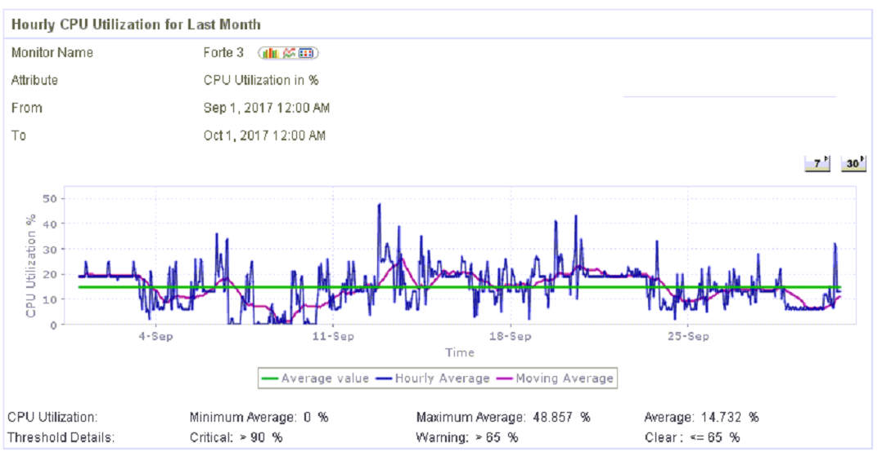

The CPUs are not all busy at the same time. Some of them are still idle, which allows the processes to flow without interruptions.

Memory Usage

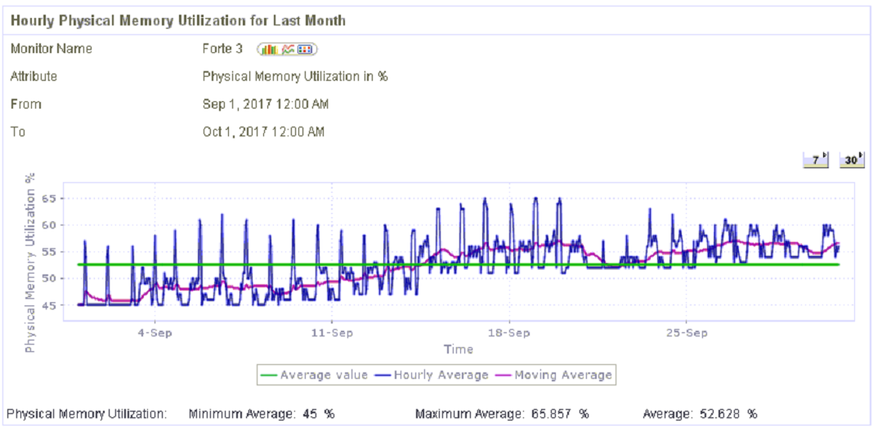

There are no peaks in memory usage.

2.2 FORTE5

Server Specs

|  |  |
| --- | --- |
| **Server Name** | FORTE5 |
| **Domain** | Airlinkjbl.ae |
| **Server Model** | IBM x3650 M3 |
| **Processor Model** | Intel Xeon E5-2630 v3 |
| **Processor Speed** | 2.40 GHz |
| **Number of Cpu's** | 16 |
| **Ram** | 24 GB |
| **OS** | Windows Server 2008 Ent SP2 |
| **OS Mode** | 32 bit |
| **IP Address** | 192.168.3.229 |
| **Subnet Mask** | 255.255.255.0 |
| **Default Gateway** | 192.168.3.2 |
| **DNS Server 1** | 192.168.3.225 |

Figure 18: Server Specifications

Server Uptime

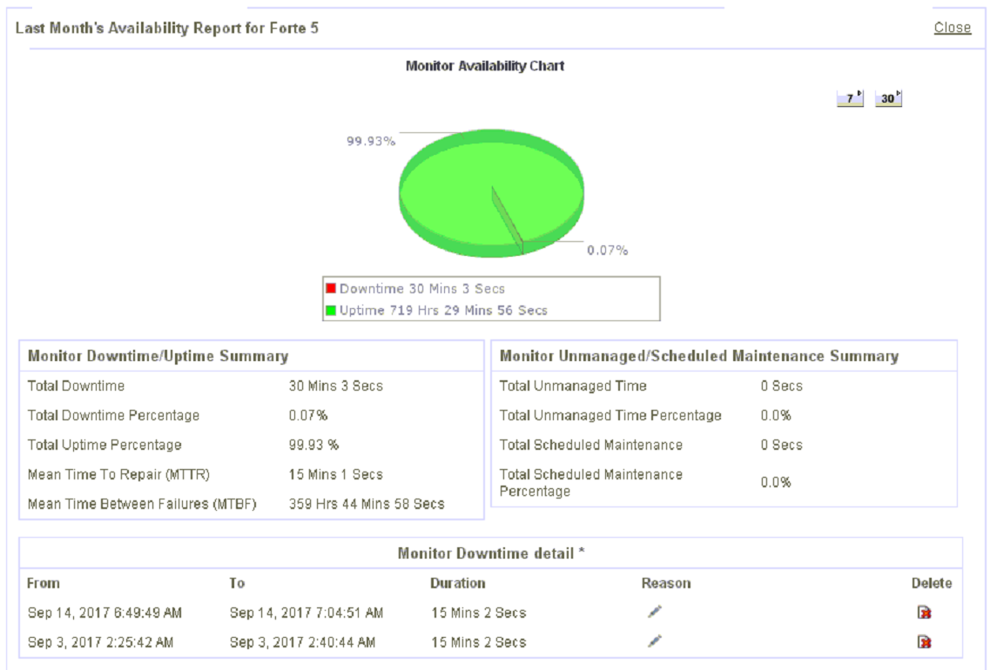

The FORTE5 server has been up 99.93% of the time during the past month. Several downtimes of 15 mins have been reported during the first two weeks of September. This underlines that there are few disconnections happening in the network and might affect the WMS uptime in the future.

Disk

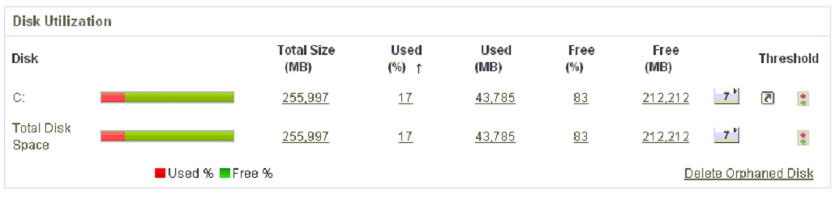

Server Overview

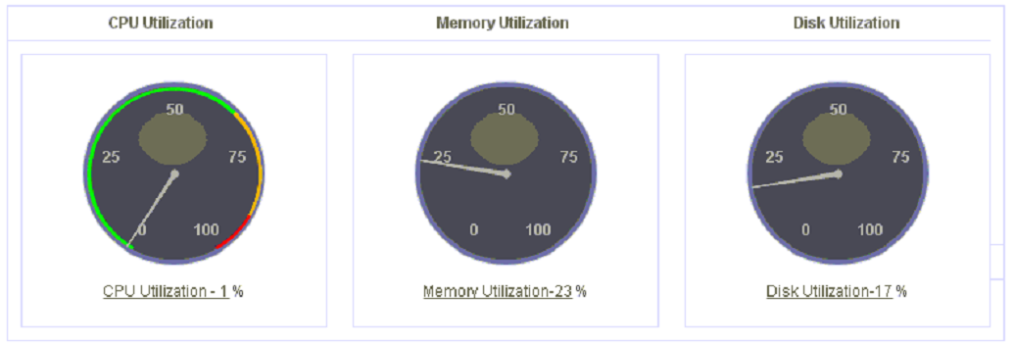

Error Logs

No error logs were found in event viewer or forte logs.

CPU Usage

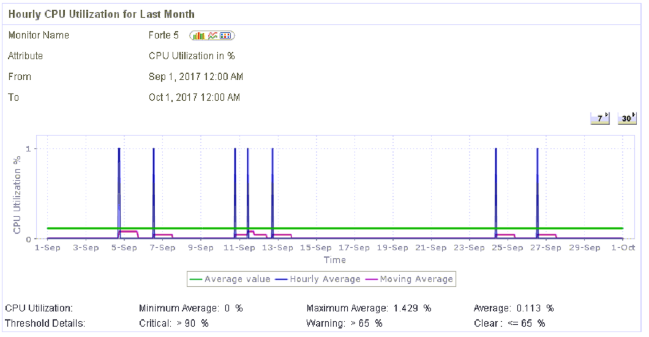

The CPUs are not all busy at the same time. Some of them are still idle, which allows the processes to flow.

Memory Usage

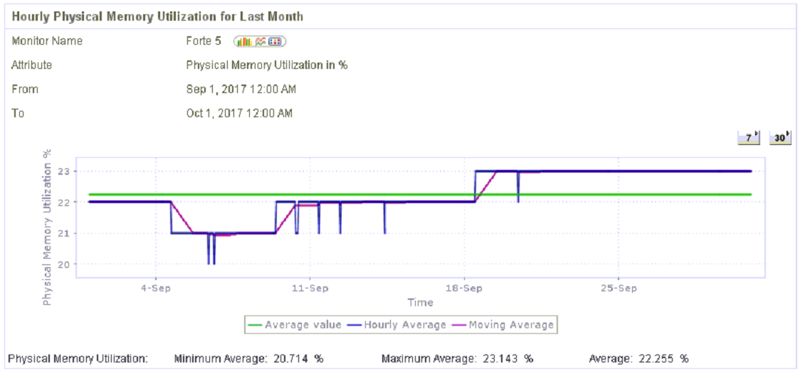

There are no peaks in memory usage.

1. Boomi Report

Title of Chapter

Boomi Server Specs

|  |  |
| --- | --- |
| **Server Name** | BOOMISERVER |
| **Domain** | Airlinkjbl.ae |
| **Server Model** | IBM x3650 M3 |
| **Processor Model** | Intel Xeon E5620 |
| **Processor Speed** | 2.40 GHz |
| **Number of Cpu's** | 8 |
| **Ram** | 8 GB |
| **Partition 1 'C:'** | 135 |
| **Partition 2** | N/A |
| **OS** | Windows Server 2003 R2 Ent SP2 |
| **OS Mode** | 32 bit |
| **IP Address** | 192.168.75.210 |
| **Subnet Mask** | 255.255.255.0 |
| **Default Gateway** | 192.168.3.2 |
| **DNS Server 1** | 192.168.3.225 |

Figure 20: Server Specifications

Disk

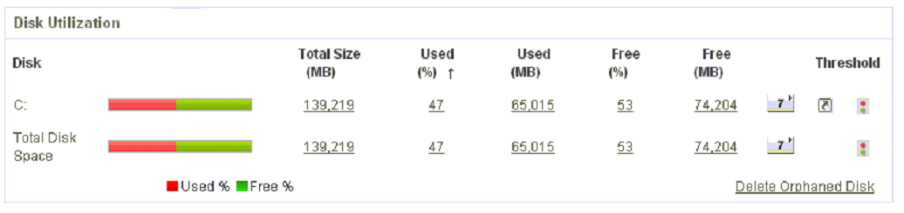

Server Overview

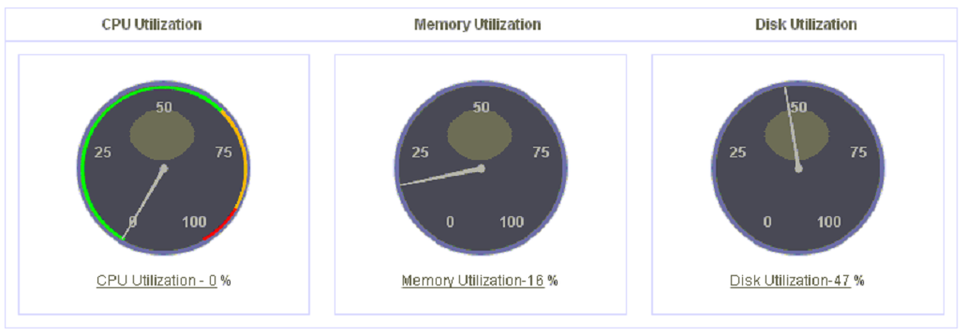

Error Logs

No error logs were found in event viewer.

CPU Usage

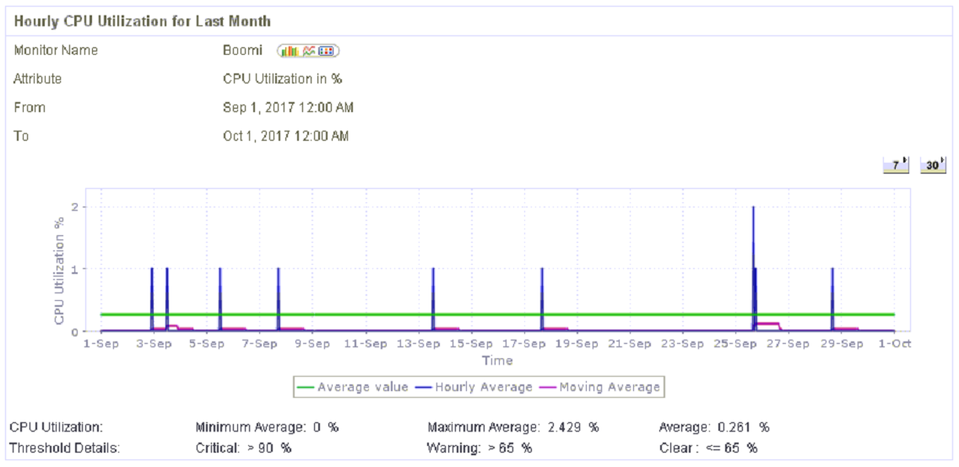

The CPUs are widely available.

Memory Usage

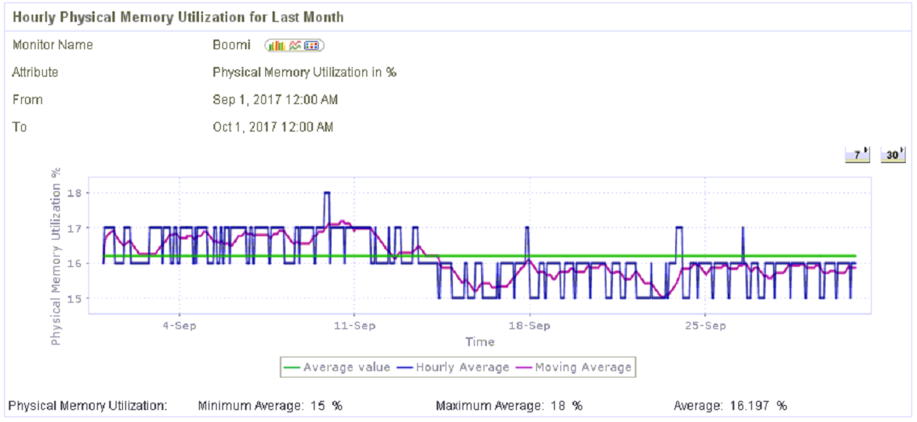

There are no peaks in memory usage.

Boomi Application Logs

Boomi Alerts

*Observations*

Boomi Alert Logs underline that there is a problem in the SMTP connection, preventing emails and notifications from being sent.

The Boomi Integration and Application Logs and archive occupy more than 20GB.

*Notes*

Airlink IT to look into the connection problem between Boomi and the SMTP server.

Otherwise, the 22GB occupied by the Boomi Logs/Folder do not pose a threat or risk over the server’s total memory.

Boomi Database

The Boomi tables do not need to be archived.

The Boomi logging has been set to “Errors only” in the Boomi database.

During the past month, Boomi database’s “system” tablespace has been extended through the addition of one data file.

1. Miscellaneous

No miscellaneous activities were noted during this month.

1. Acknowledgment

|  |  |  |
| --- | --- | --- |
| Acknowledged on behalf of SNS: |  | Acknowledged on behalf of Airlink: |
| __________N___________ Signature |  | _______________________ Signature |
| ___Technical Consultant____ Title |  | _______________________ Title |
| ____Nareg Adalian_____ Print Name |  | _______________________ Print Name |
| ______02/10/2017________ Date |  | _______________________ Date |